|  |
| --- |
| VIETNAM NATIONAL UNIVERSITY SOCIALIST REPUBLIC OF VIETNAM  HO CHI MINH CITY Independence - Freedom - Happiness  UNIVERSITY OF SCIENCE |
| INTRODUCTION TO COMPUTER SCIENCE FINAL PROJECT  MINESWEEPER  Student: Nguyễn Hữu Quốc Thắng – ID: 22125091 |

# Table of Contents

❖ Personal Information and Purpose of Report 3

❖ Features Implemented as per the Requirements 4

❖ Video Demo 5

❖ Instructions 6

❖ Compiling Instructions 10

- Notes 10

- On Windows 10

- On Linux 10

❖ Functions 11

❖ Program Flow 13

- The main() function 13

- Starting a new game 16

- Generating an empty game field 20

- Game logic 23

- Make your next move 25

- Cell flagging 27

- Cell revealing 28

- Flood-Fill, or “Revealing Nearby Empty Cells”, or “How did I spend so long for this 1 simple thing” 29

- Saving a Game 34

- Loading a Saved Game 36

❖ Personal Remarks 39

- General 39

- What I learned 39

- What needed to be improved 39

# Personal Information and Purpose of Report

* My name is: Nguyễn Hữu Quốc Thắng - Class: 22TT2 - ID: 22125091
* I have signed up for the Project of the CS161 Course at the beginning of the course, alongside doing the Lab Homework.
* This report will be reflecting on the progress made throughout 10 weeks of doing this project, as well as describing how the game runs, and the implementation/usage of the functions implemented in the game.
* Project name: *RookieSweeper*
* Reason to choose it: because I still have too much to learn.
* GitHub Repo of Project: <https://github.com/Rookie001MC/Minesweeper-Project>

# Features Implemented as per the Requirements

* Board drawing (cells, mines, flags)
* Cell state changing when selected
* User-specified board size, new game menu, flagging and revealing cell menu
* Randomized mine positions
  + Sometimes the user may accidentally reveal the cell containing the mine in the first move, resulting in a very fast Game Over. Therefore, this feature can be considered incomplete.
* Cell selection
* Game saving and loading
  + This feature can still be considered incomplete, as there is a possibility that a save file with invalid format can still be accepted by the game.

# Video Demo

* <https://streamable.com/1oq5ih>

# Instructions

1. Double-click on the game to launch, this will take you to the main menu: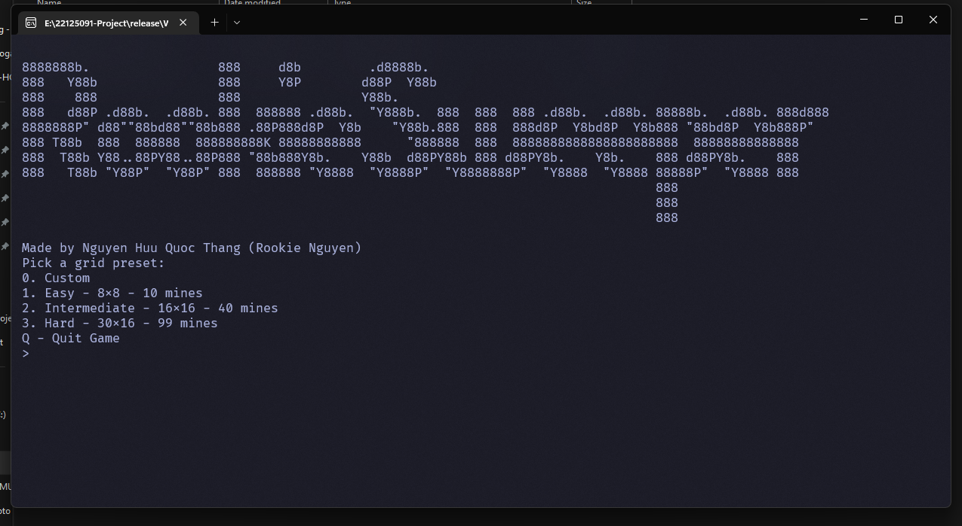
2. Select your desired difficulty:
3. Time to play Minesweeper!
   1. Use R or F to Reveal a cell:
   2. For cells that have been flagged, if you flag them again, it will change the state to Unsure, and if is Unsure, will switch to normal.
   3. If you revealed a mine, game over!
4. You can save the game for the next play session:
5. Then the next time you launch the game, it will prompt you if you want to continue the last game:

# Compiling Instructions

## Notes:

* + This game tried to be as cross platform as possible, while only using STD libraries, so this can be compiled and run on Windows and Linux (I couldn’t test on MacOS because I do not have any MacOS device).

## On Windows:

* + Requirements:
    - Visual Studio 2022 or later with the *“Desktop Development with C++”* workload
  + Double click on the .sln file to open the project
  + Click on Build 🡪 Build Solution to build
  + The resulting output will be in release/Windows-x64/RookieSweeper-Windows-x64.exe.

## On Linux:

* + - Either use the provided `build-linux.sh` script:
      1. Enable script to be executable:  
         chmod +x `build-linux.sh`
      2. Run the script:  
         ./build-linux.sh
    - Or compile manually:
      1. Execute command to build the project:  
         g++ -o ./release/Linux-x64/RookieSweeper-Linux-x64 ./src/*.cpp -std=c++20
    - In either case, the resulting output will be in release/Linux-x64/RookieSweeper-Linux-x64.

# Functions

* The project is spanned across 3 files:
  + main.cpp: The main entry point for the game, which contains most of the game flow functions
  + util_functions.cpp: Contains the functions that deal with other functionalities of the game, including: checking valid cells, asking the user for their desired cell, check file saves, …
  + minesweeper.hpp: Defines the Minesweeper Cell struct and the functions.
* There are 23 functions, not including main():
  + 7 of which are tied to the gameplay flow: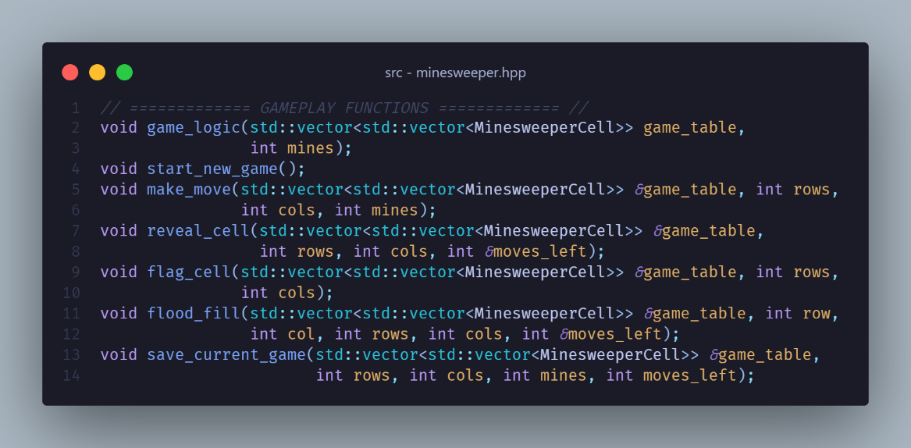
  + The remaining 16 does not actually belong to the gameplay but are important for the functionally of the game (I call them ‘utility’ functions):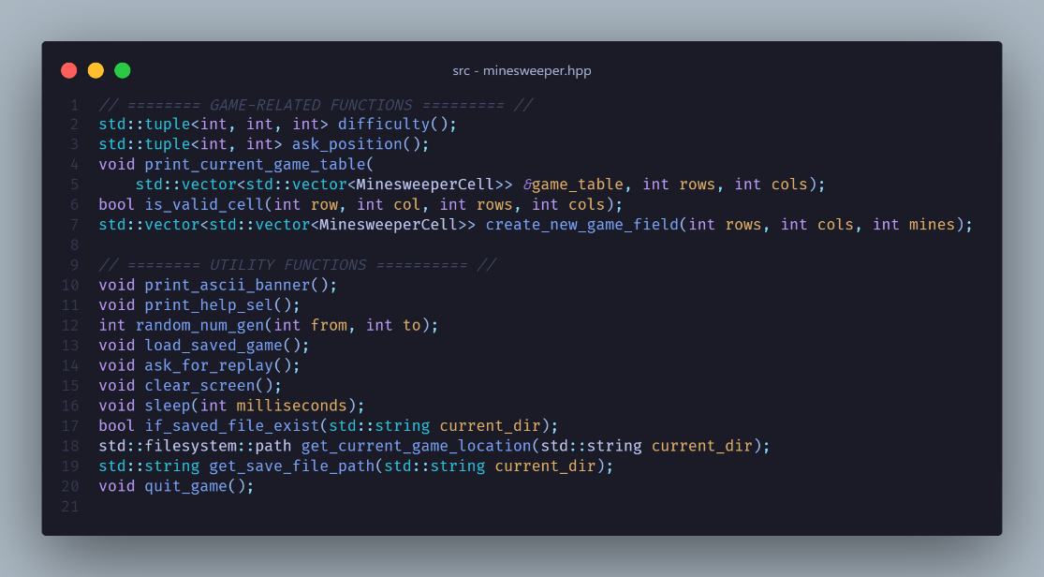
* A cell in the Minesweeper game is defined in the struct below, with an enum to define the Flag status: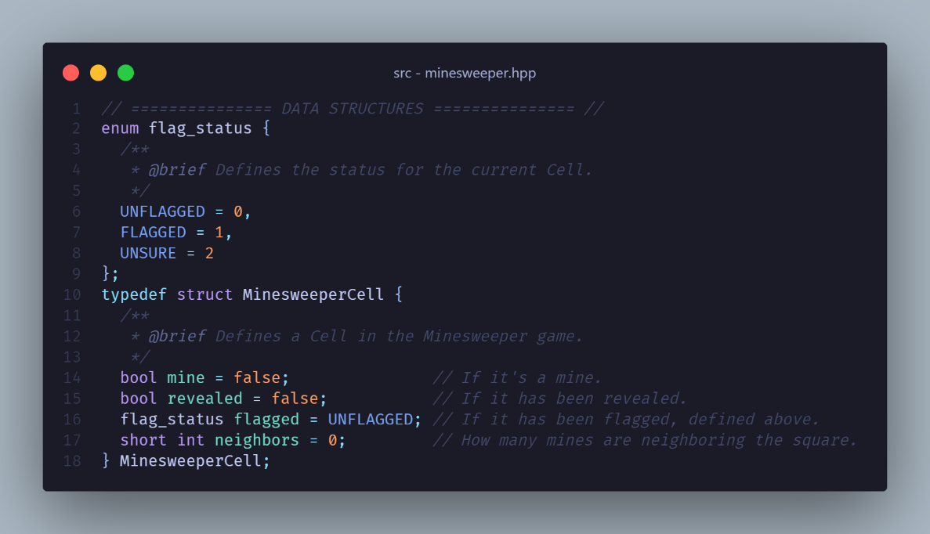

# Program Flow

## We start at the main() function:

* + - First off, the game prints the welcome banner: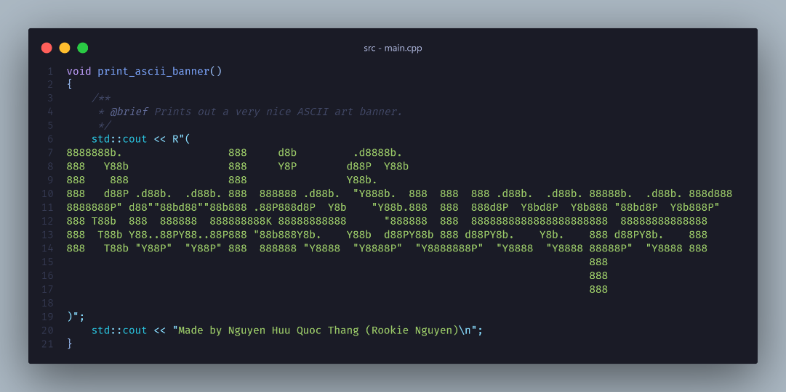
    - Then, it checks if a game save file is present at where the game is located: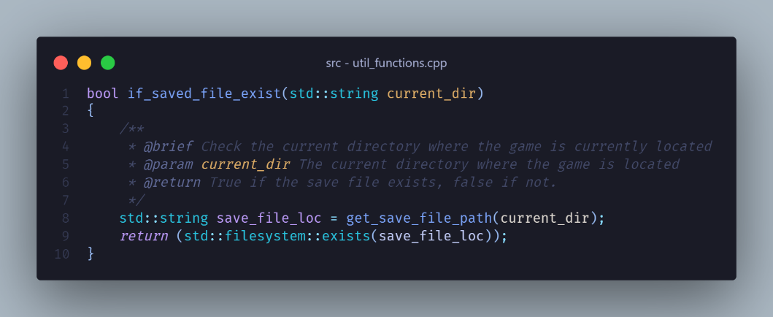 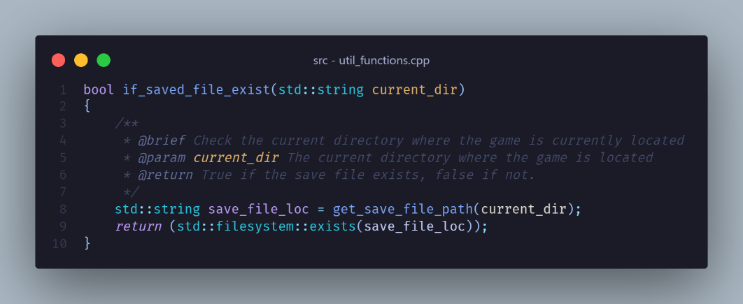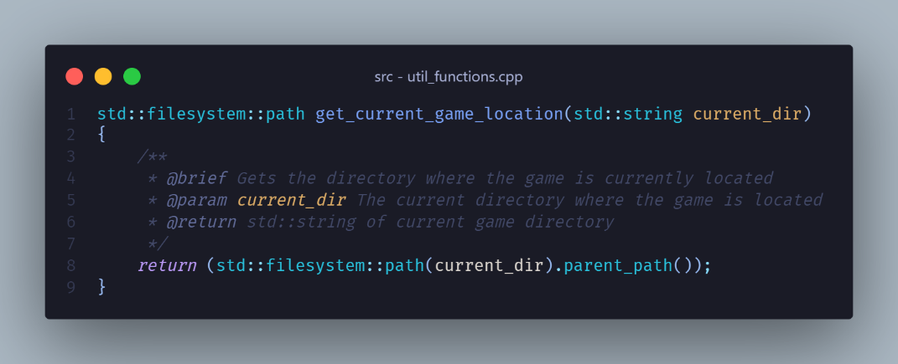
    - If there is, the game will prompt the user if they want to load the save file.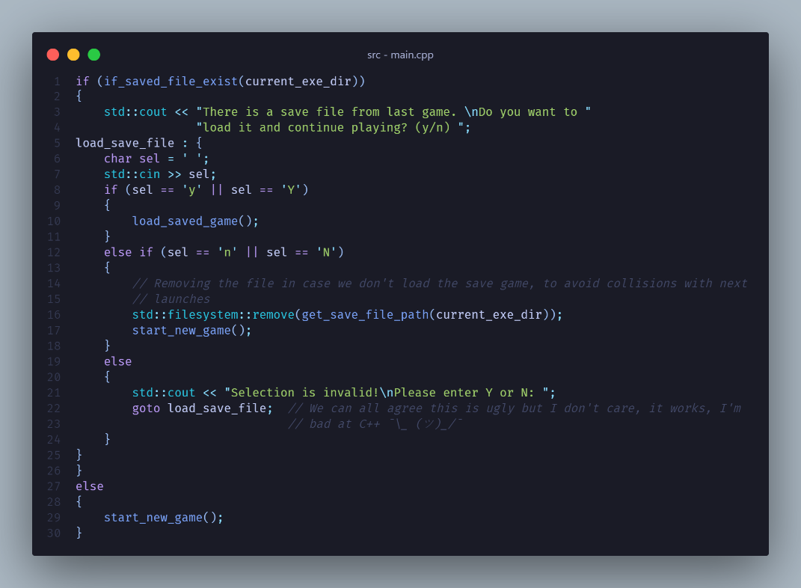
      * If we accept, we will load the save file, and if we don’t, we’ll delete the save file and start a new game.
      * If the user types a wrong input, other than Yes or No, the game will reprompt.
        + I decided to use goto here, primarily because it’s a pain to write another while loop to reprompt the user, and it’s much cleaner in my opinion.
    - If there is no save file, we can just start a new game immediately.

## Starting a new game:

* + - Starts by calling difficulty() to ask the user for the desired difficulty: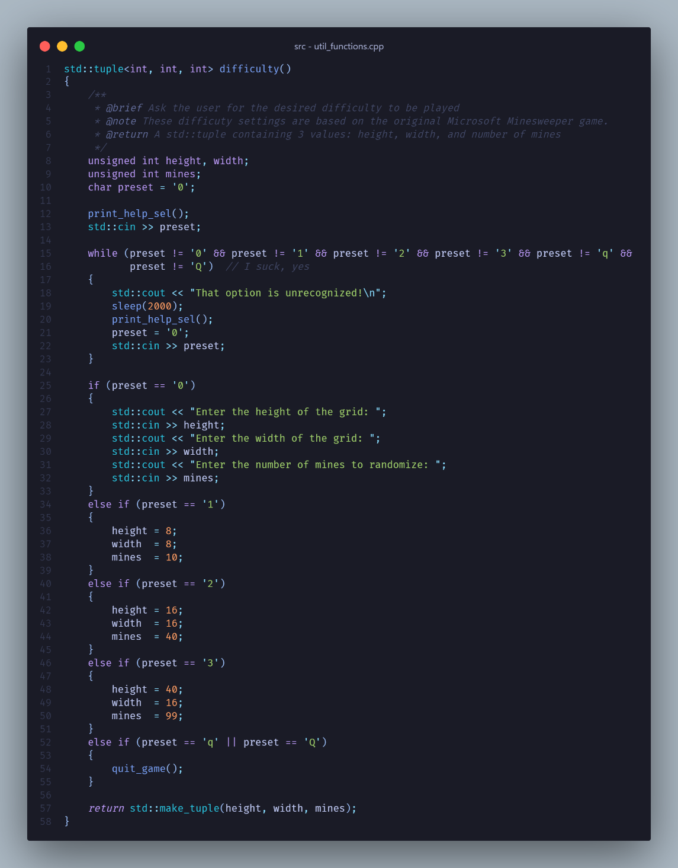
      * First, print the main menu to the user: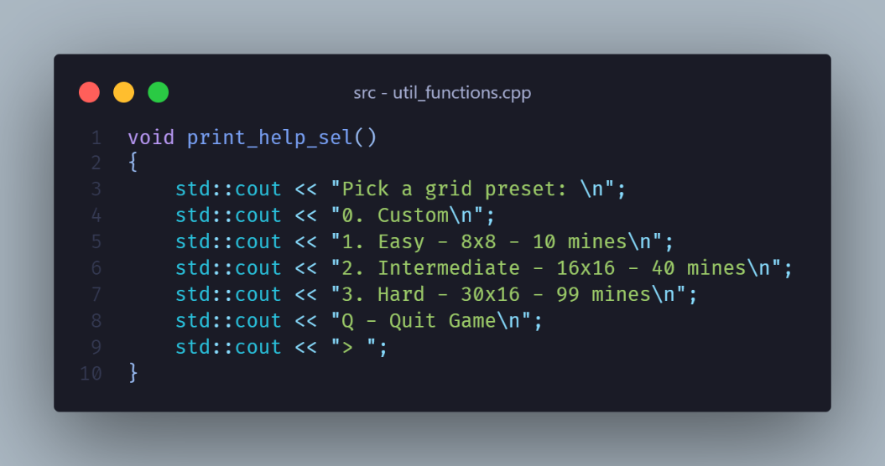
      * We then wait for the user input:
        + If the input is invalid, we reprompt: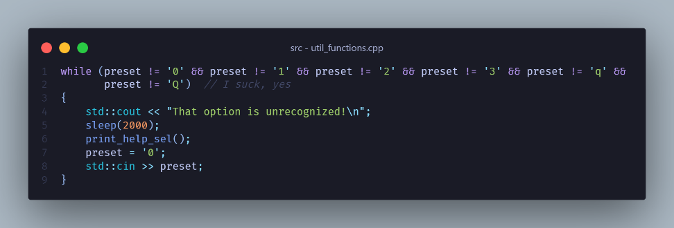
        + Else if the selection is valid: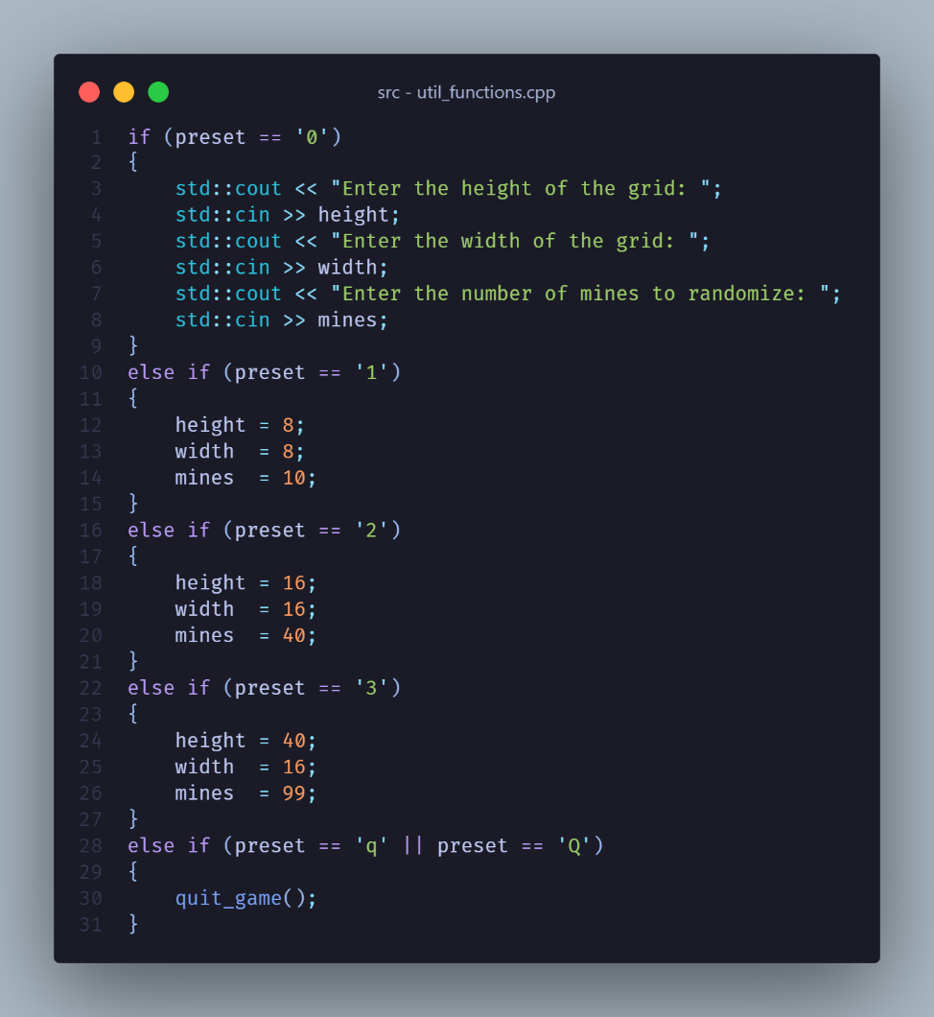
        + Then we return the height, width and mines, as a 3-element tuple: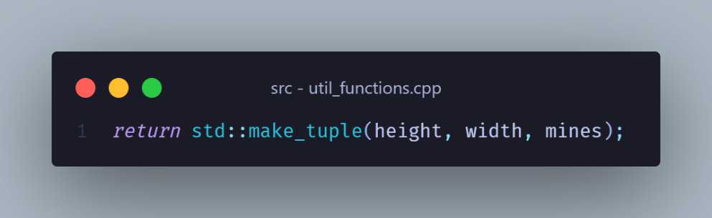
      * Once we have enough information, it’s time to initialize the variables: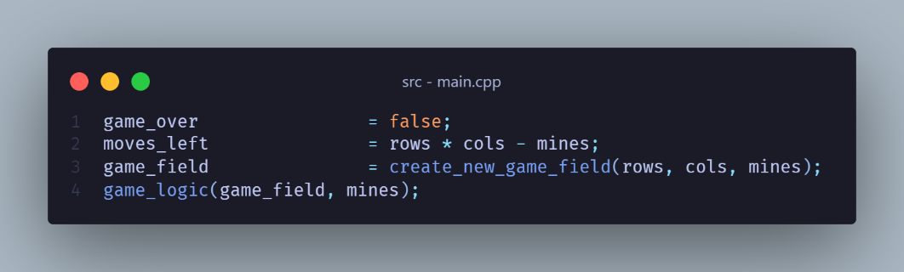
      * Which we will also generate a new game board before handing off to the game_logic():

## Generating an empty game field: Text Description automatically generated (it’s too long so I only capture the comments)

* + - We first generate a 2D STD::vector to store the current state of the game table, with the size of rows x cols, and then fill it with empty cells: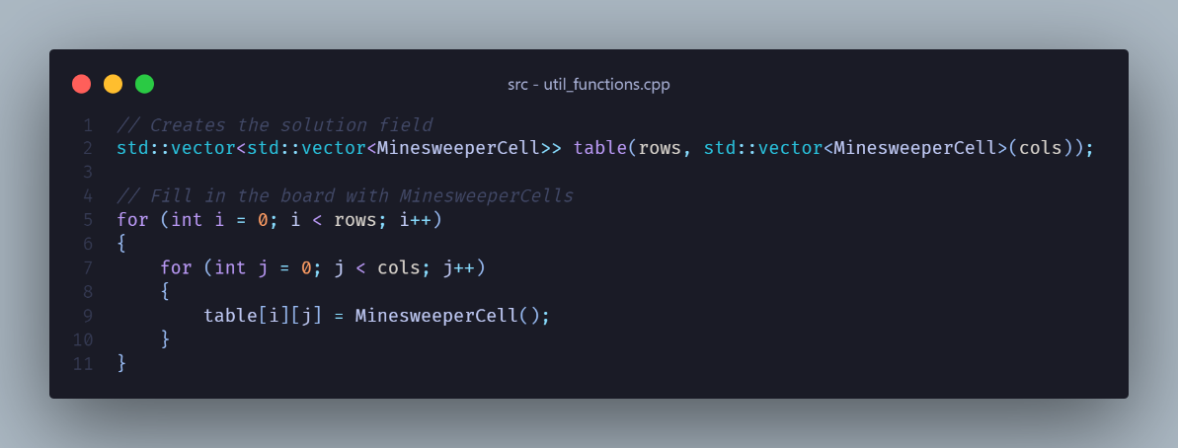
    - Then we begin inserting the mines into the cell: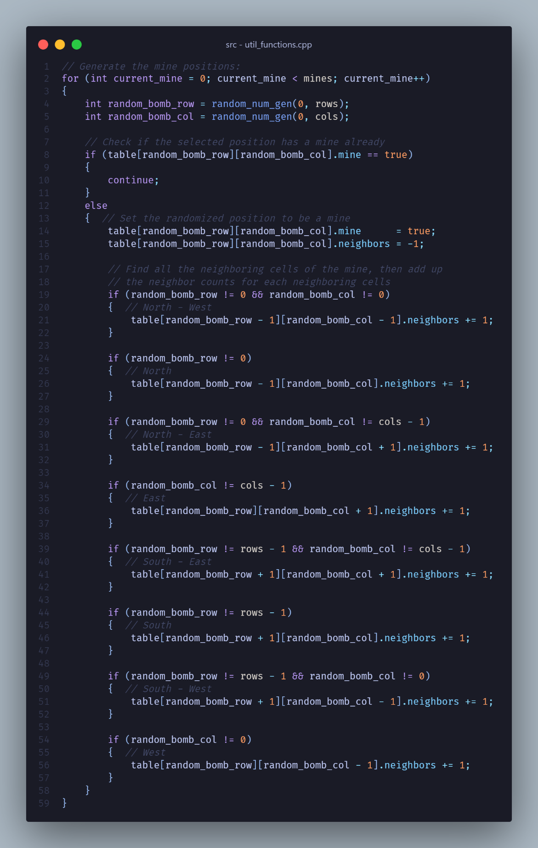
      * I implemented my own number generator, just for fun, which is based on the Mersenne-Twister engine, based on an implementation [here](https://learn.microsoft.com/en-us/cpp/standard-library/random?view=msvc-170#:~:text=While%20these%20are%20high%20quality%20random%20numbers%20and%20different%20every%20time%20this%20program%20is%20run%2C%20they%20are%20not%20necessarily%20in%20a%20useful%20range.%20To%20control%20the%20range%2C%20use%20a%20uniform%20distribution%20as%20shown%20in%20the%20following%20code%3A):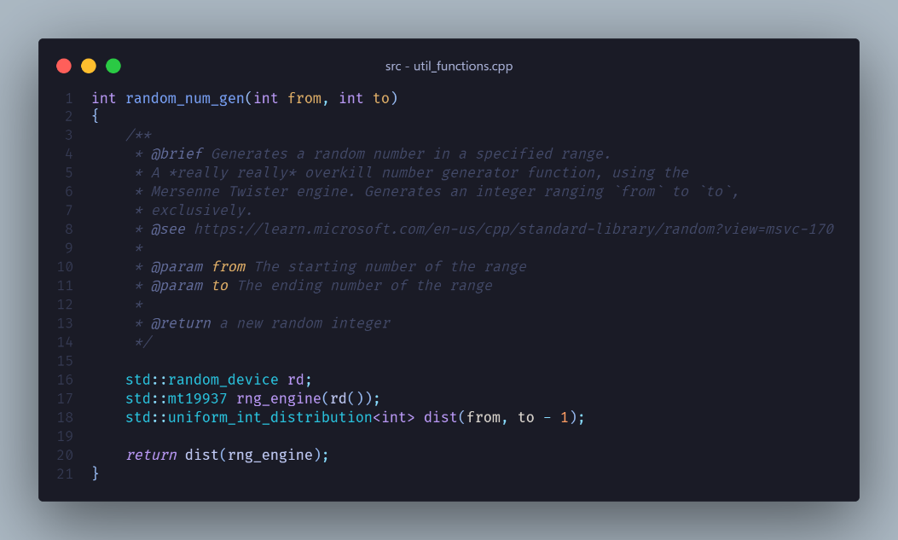
    - Once finished, we can return the newly generated table so that we can pass it to game_logic().

## Game logic:

* + - First, we get the rows and cols of the current table, then we run it as an infinite loop when game_over is false: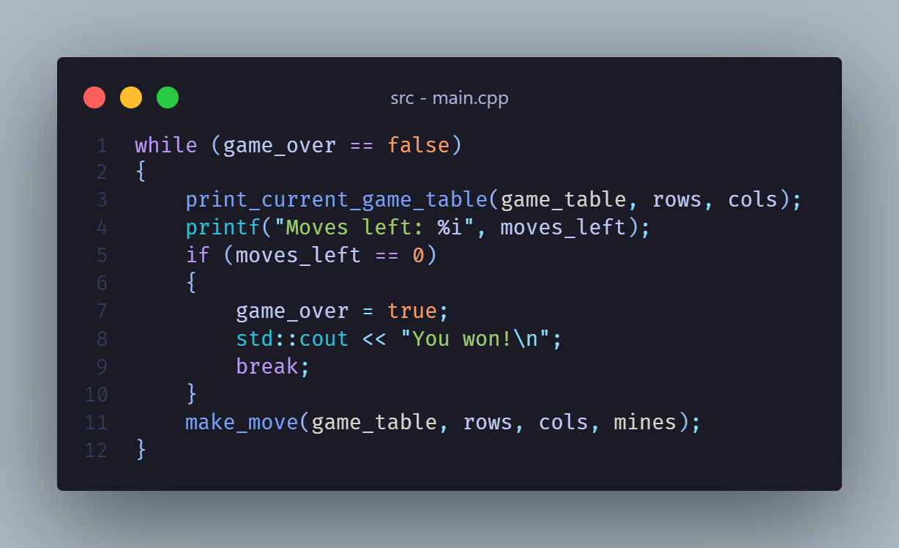
    - The game constantly keeps track of the remaining valid moves and the game over state.
      * If there are no more valid moves, then that means the player has successfully opened all the non-mine cells. At this point, we set the game_over to true, and break out of the while loop.
      * If the player reveals a mine, then we will set the game_over variable in the make_move() function, which we’ll get to later.
      * In any case, once the game has ended, we ask the user if they want to play again: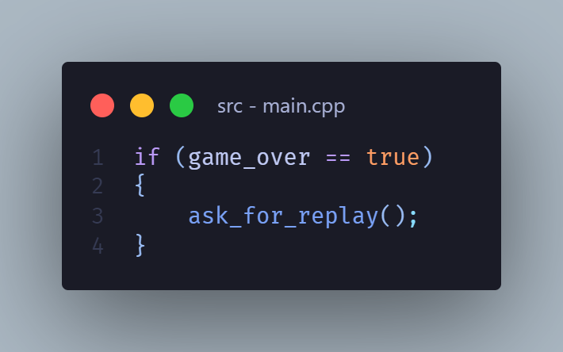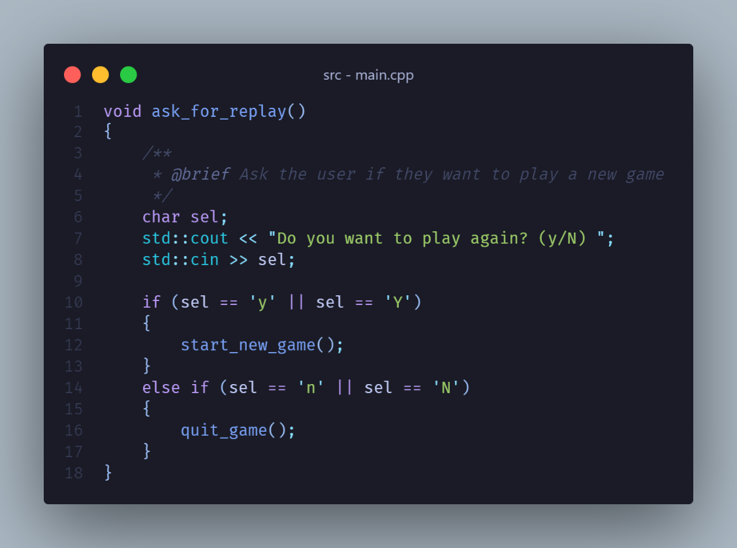
      * If they agree, a new table will be generated, and the game logic continues, but if they disagree, the game will simply exit.
    - At this point, if the game is still happening as normal, we can now ask the player for their next move.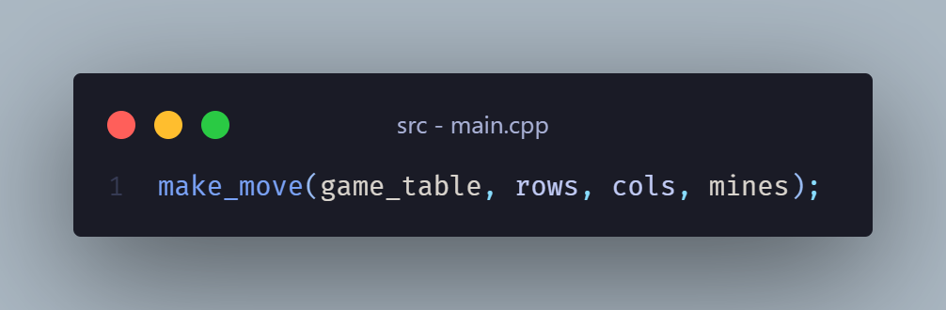

## Make your next move:

* + - The game will now ask the user for their selection as above.
    - If they type an invalid choice, it will notify and reprompt the user for their selection.
    - If the user decides to quit the game, it will check if the user has saved the game and notify them: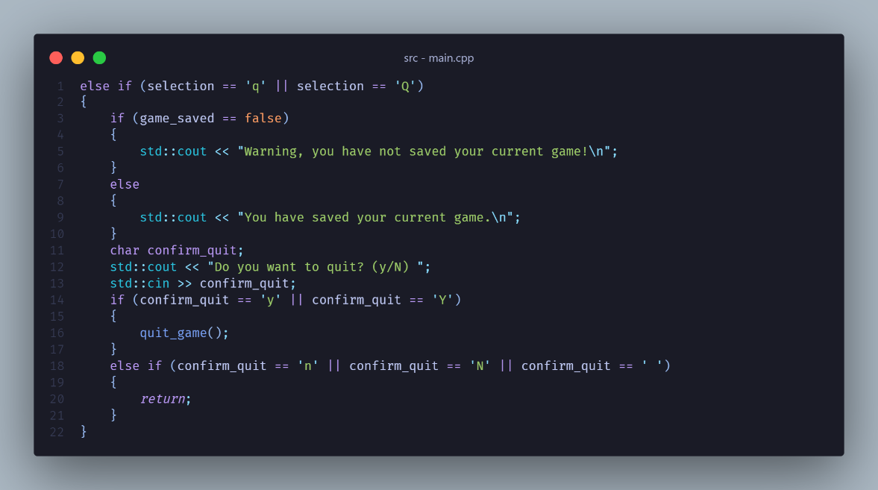
    - If they want to reveal or flag a cell, then it will first ask for the user for the cell position and then verify it: 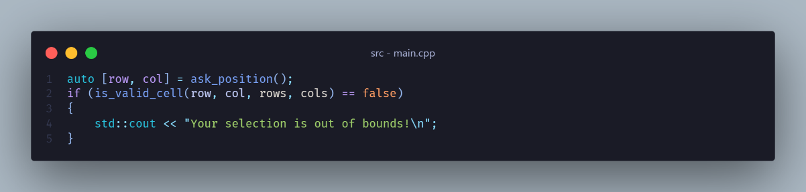 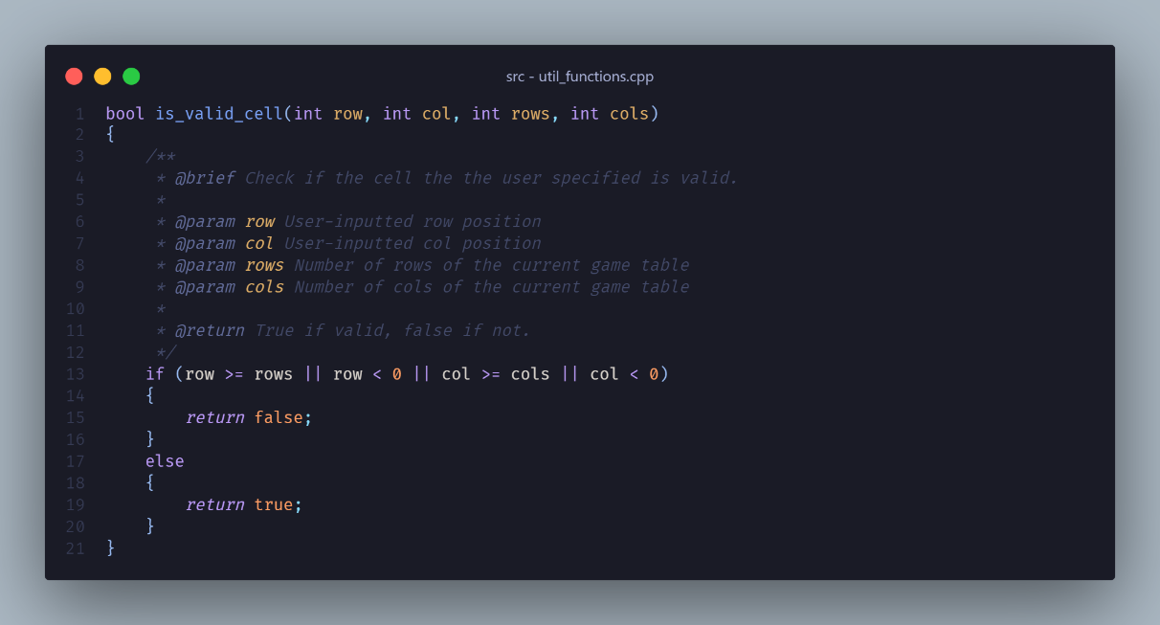
    - If all is correct, then further processing will be done depending on the user’s selection.
    - If the user decides to save the game for later, then the game will save the current board state for next session.
    - In any case, after receiving the user’s input, we wait for 500ms, clear screen, then print the current game table, then wait for user input, then repeat.

## Cell flagging:

* + - I decided to cover the flagging cell first, because it’s more straightforward than revealing the cells.
    - First, after asking for the user’s input and verifying it, the selected cell will be checked if it has already been revealed, and if it has, then block it from being flagged.
    - Then that cell will be cycled in the order:

UNFLAGGED 🡺 FLAGGED 🡺UNSURE 🡺UNFLAGGED

* + - Once done, it will be printed to the user.

## Cell revealing:

* + Just like the flagging cell function, it also asks and then verify the user’s input, but this time, it also checks if the cell is flagged.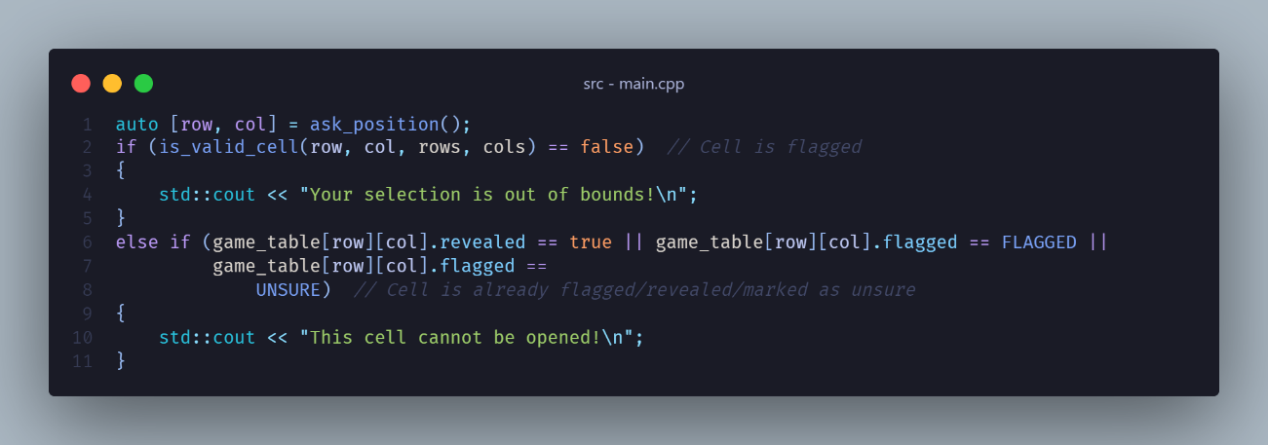
  + When everything is good, we begin to process further: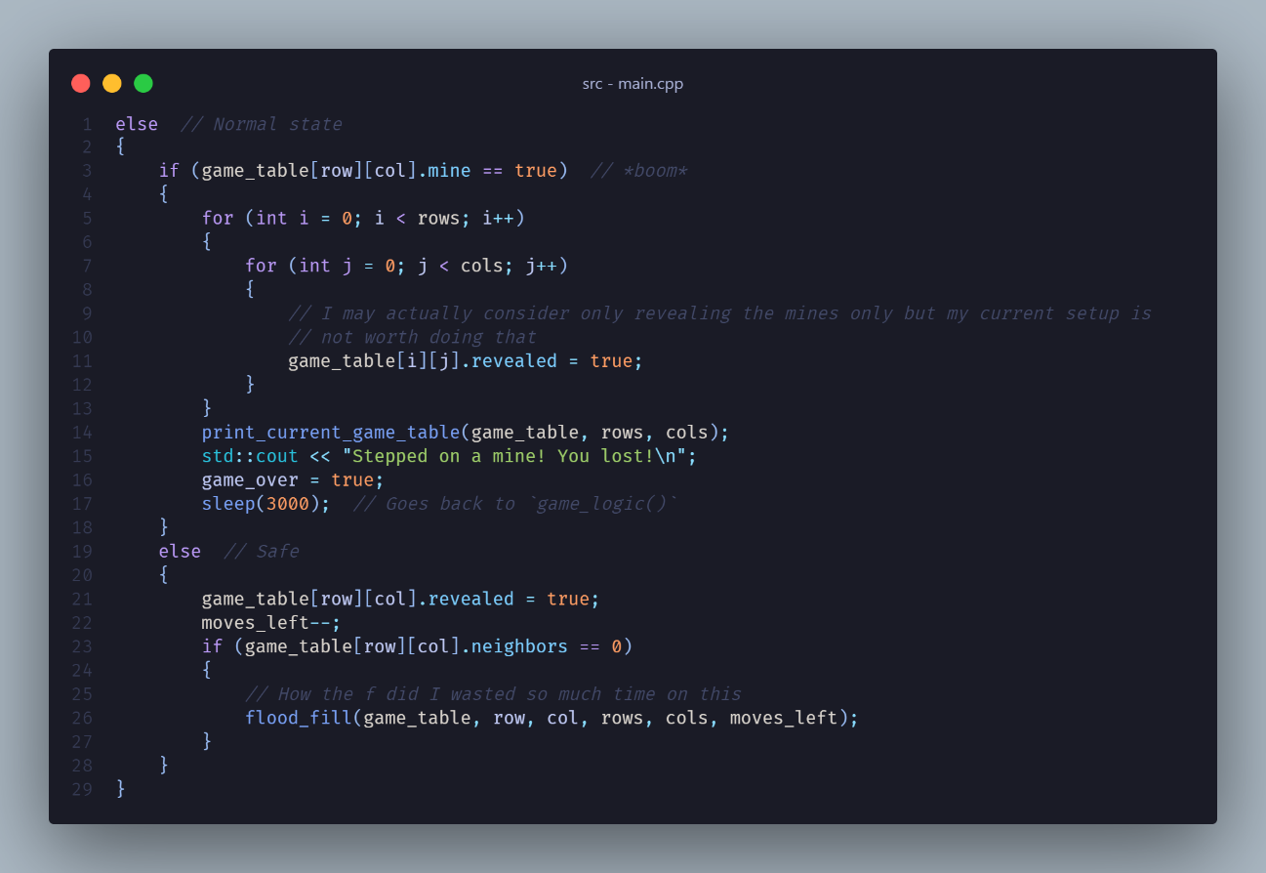
  + If the cell revealed is a mine, we reveal every single cell, print it to the user, set the game_over to true, and then return to game_logic(), where it will ask if the user want to play a new game or not.
  + But if it’s an empty cell, we can start to reveal it and other nearby empty cells using flood-fill.

## Flood-Fill, or “Revealing Nearby Empty Cells”, or “How did I spend so long for this 1 simple thing”:

* + *“Flood fill, also called seed fill, is a flooding algorithm that determines and alters the area connected to a given node in a multi-dimensional array with some matching attribute.”*
  + In other words, we start at an *initial node*, in Minesweeper’s case, a cell in a game table, and we alter the area connected to that node, with *some matching attribute*, that is, opening other empty cells until encountered nearby mines.
  + The algorithm is akin to using the Fill tool in Paint, where it will fill areas of similar color with other color.
  + How I implemented this algorithm: 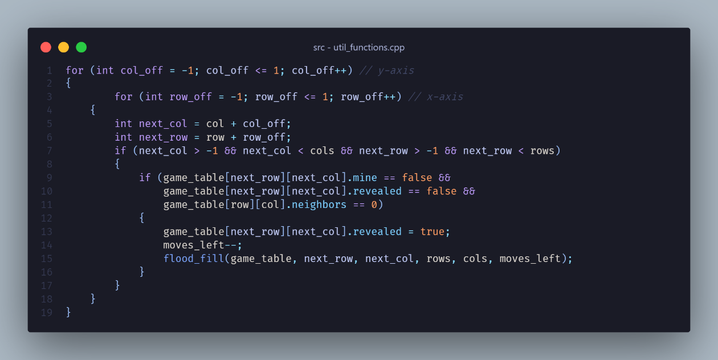
    - Assuming we have the table as below: 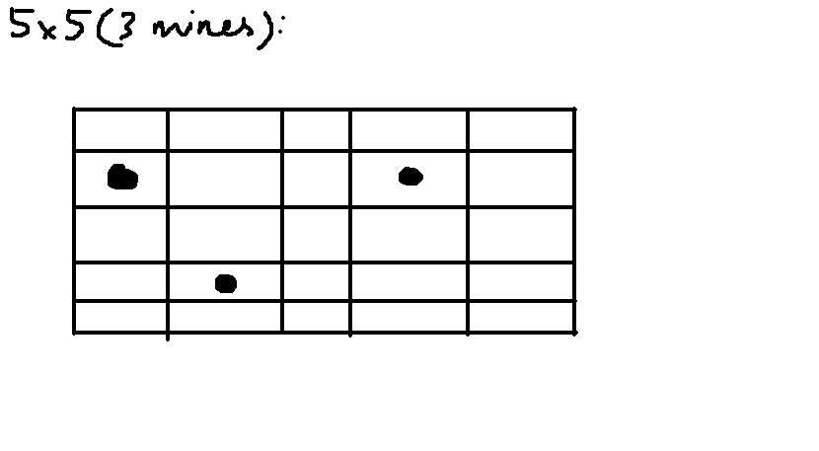
  1. First, we start off at the empty cell, say (5;5):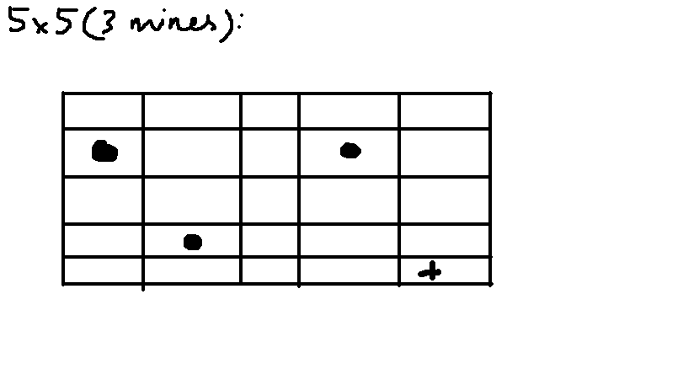
  2. On the first iteration, the current row and col offset is (-1; -1), so we’re going to take the current position, and add the offset to get the new position. In this case, (5; 5) will be (4; 4): 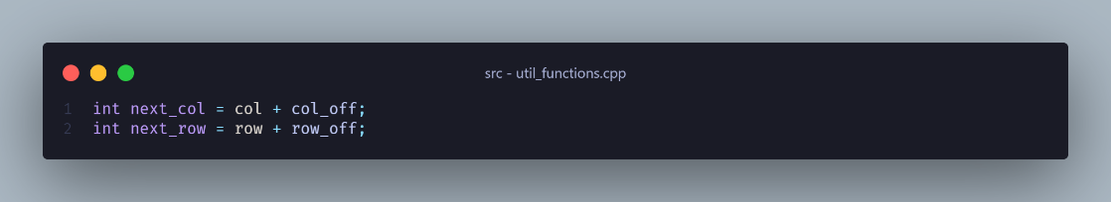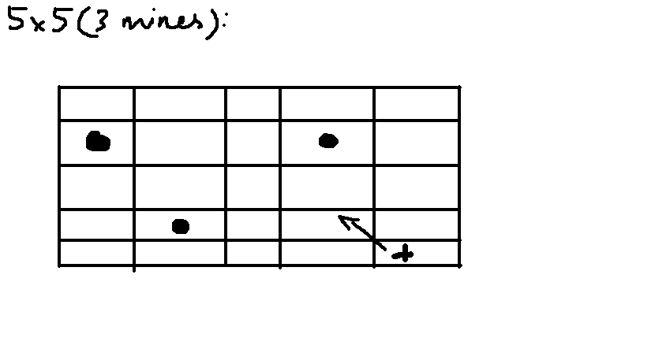
  3. We now check if the next cell has all the conditions met: 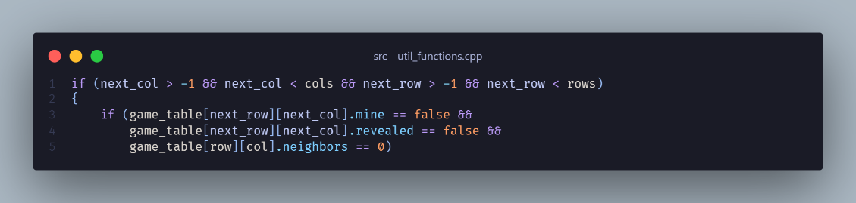
     1. If it’s in the table
     2. If it’s not a mine
     3. If it hasn’t been revealed (to avoid the next-next-cell calling the previous-next-cell)
     4. If the previous cell has no neighbors (to avoid it revealing almost every cell, effectively causing the mine position to be too obvious) (sadly I forgot to record the footage of it happening)
  4. Since the next cell satisfy all the conditions, we can now set the next cell to be revealed. At this point, we can also call the function again, this time pointing to the next position, and then repeat the procedure all over again.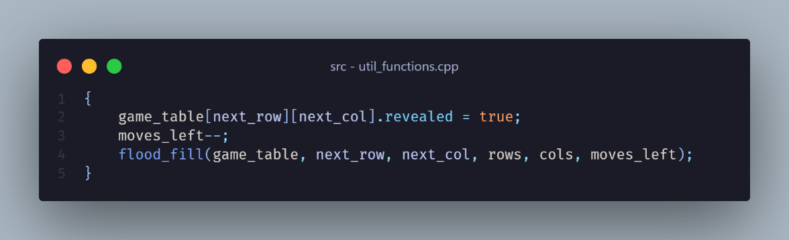
  5. This goes on until it hit a cell that does not met 1 of the previously mentioned condition. In this case, the next cell would be (2;2). However, the previous cell, (3;3) has a neighboring mine. Therefore, it returns to (4;4). 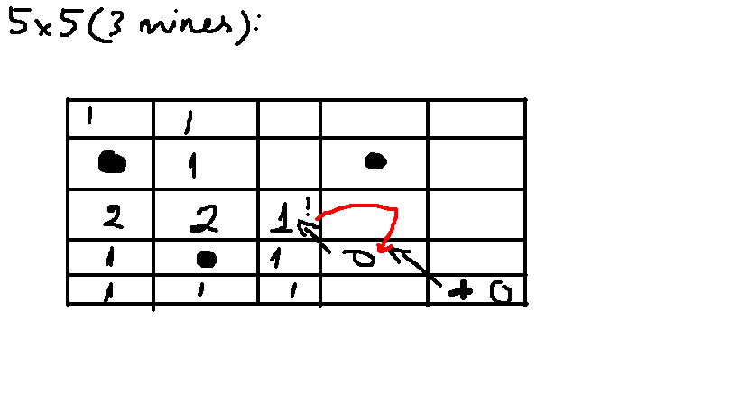
  6. Now, it’s time to increment the row offset to be 0, which means this time, the next cell will be (5, 4).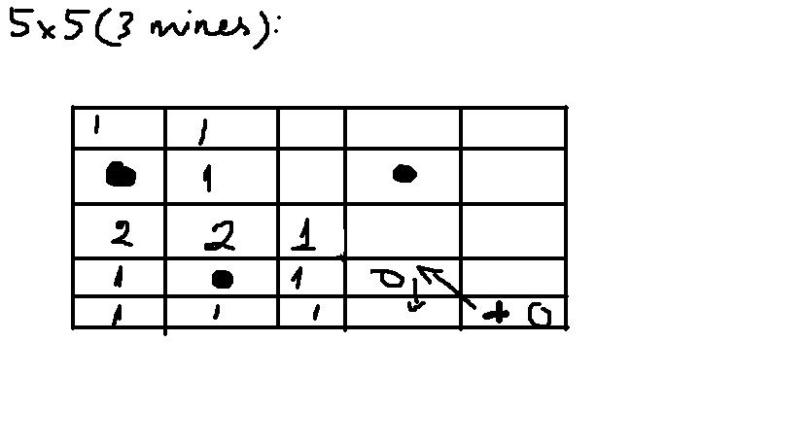
  7. Again, the cell satisfies all the condition, so we reveal it, then call the flood fill function again, this time setting the cell to be checked as (4; 3), check the condition again.
  8. And the cycle repeats all over again, until all the empty cells have been revealed.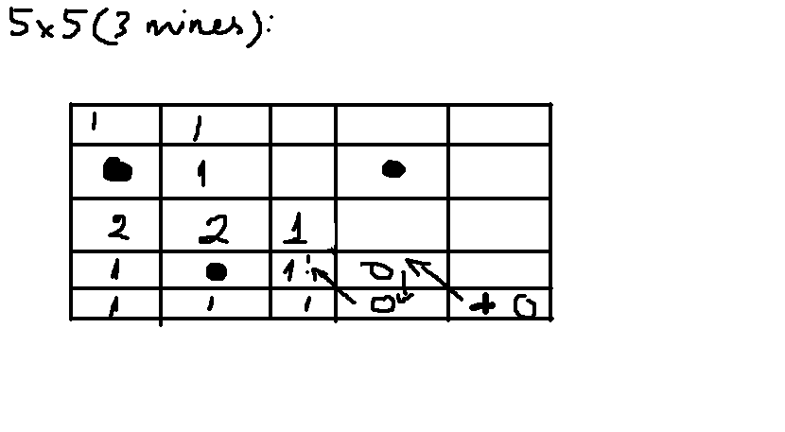
  9. Once all the non-mine cells have been revealed, the game can now continue as normal.

* + - When a game is saved, the game will first get the current path of the executable, i.e., where the game is located: 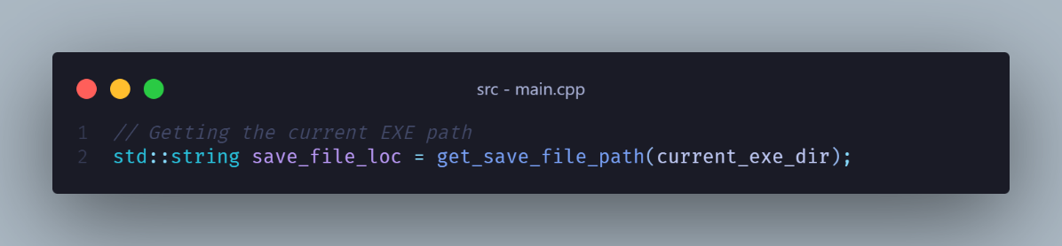
    - Then, we create a new save file and open it, with the name of game_save.txt: 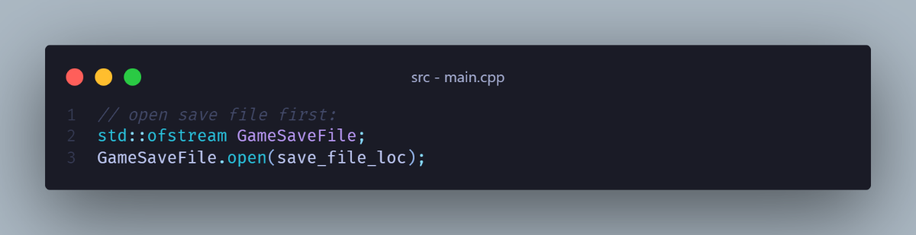
    - If the save file cannot be created, or cannot be opened, it will display an error message: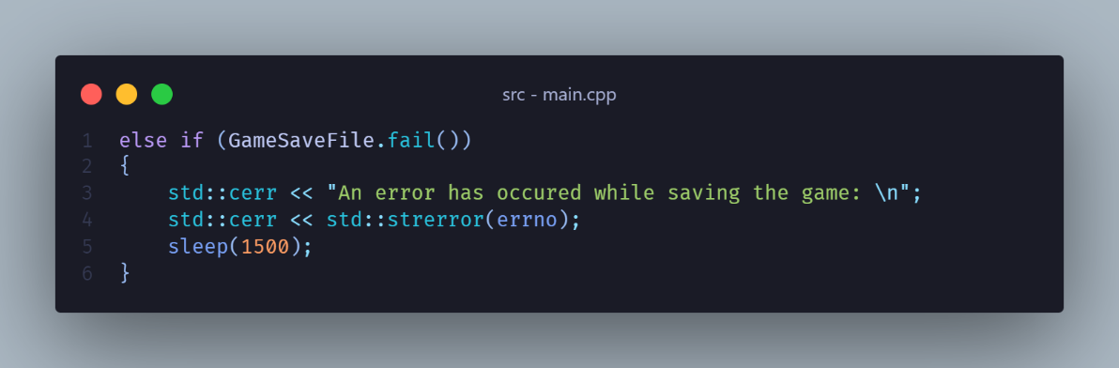
    - However, if the file has been created and opened successfully, we begin to write to the save file: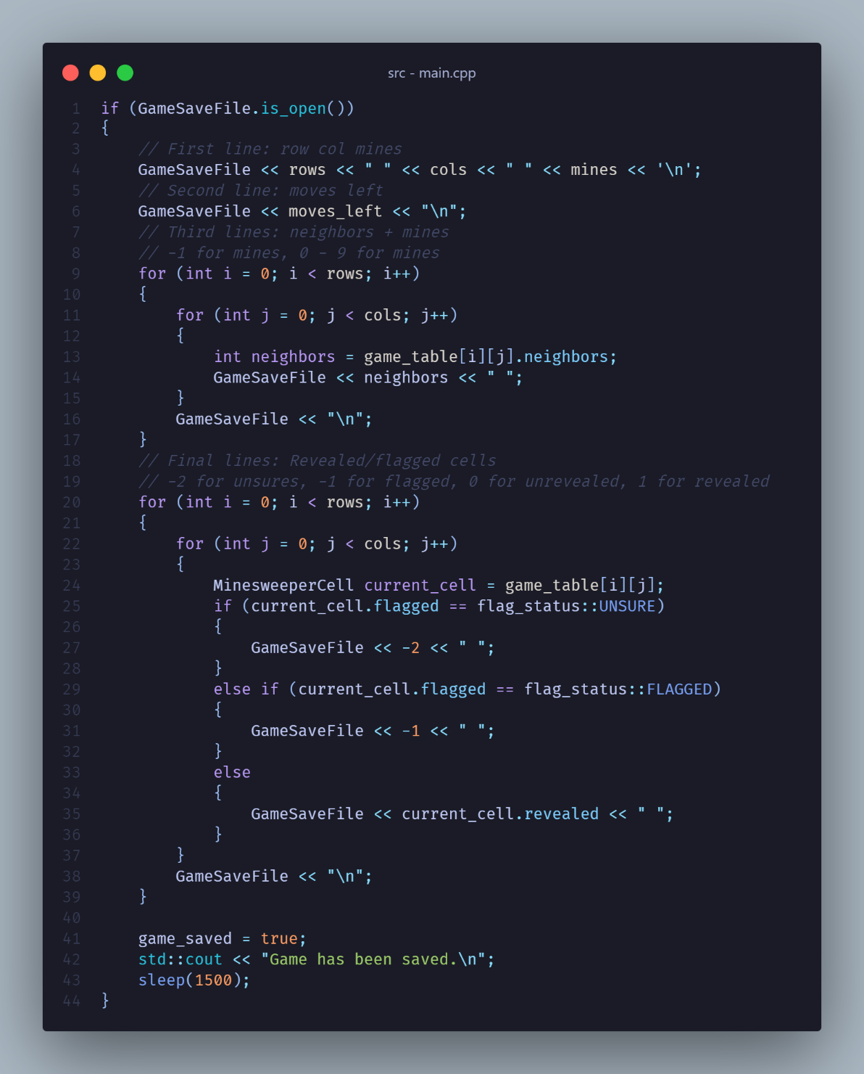
    - The result: 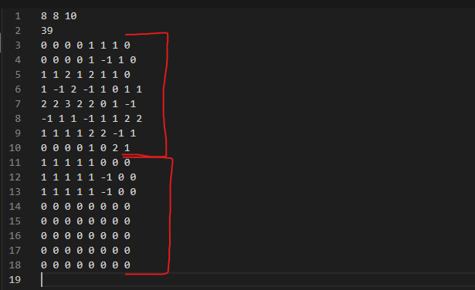
      * Line 1: Table size of row x cols, and number of mines
      * Line 2: Moves left
      * Lines 3 – 10: These contains the mines and neighboring mine counts. Mines are denoted as -1, neighboring mines are 0 – 8.
      * Lines 10 – 18: These contains the information of cells have been revealed, flagged, marked as unsure, or unrevealed. -2 is Unsure, -1 is Flagged, 0 is unrevealed, 1 is revealed.
    - After the game has been saved successfully, the game_saved variable will be set to true, then the game goes as normal.
    - Therefore, if the user were to quit mid-game, it will notify the user that the game has been saved successfully.

## Loading a Saved Game:

* + - In the main() function, the game will check if an existing game_save.txt file is found, and prompt the user if they want to load it.
    - If the user agrees, then the game can be loaded:
      * First, we get the save file path, then open the file for reading: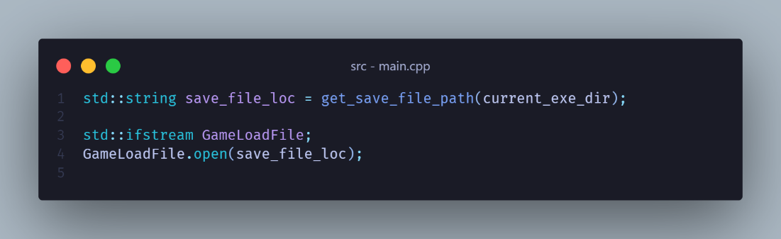
      * Afterwards, we initialize the variables that stores the data related to the game board creation, and start loading the game save: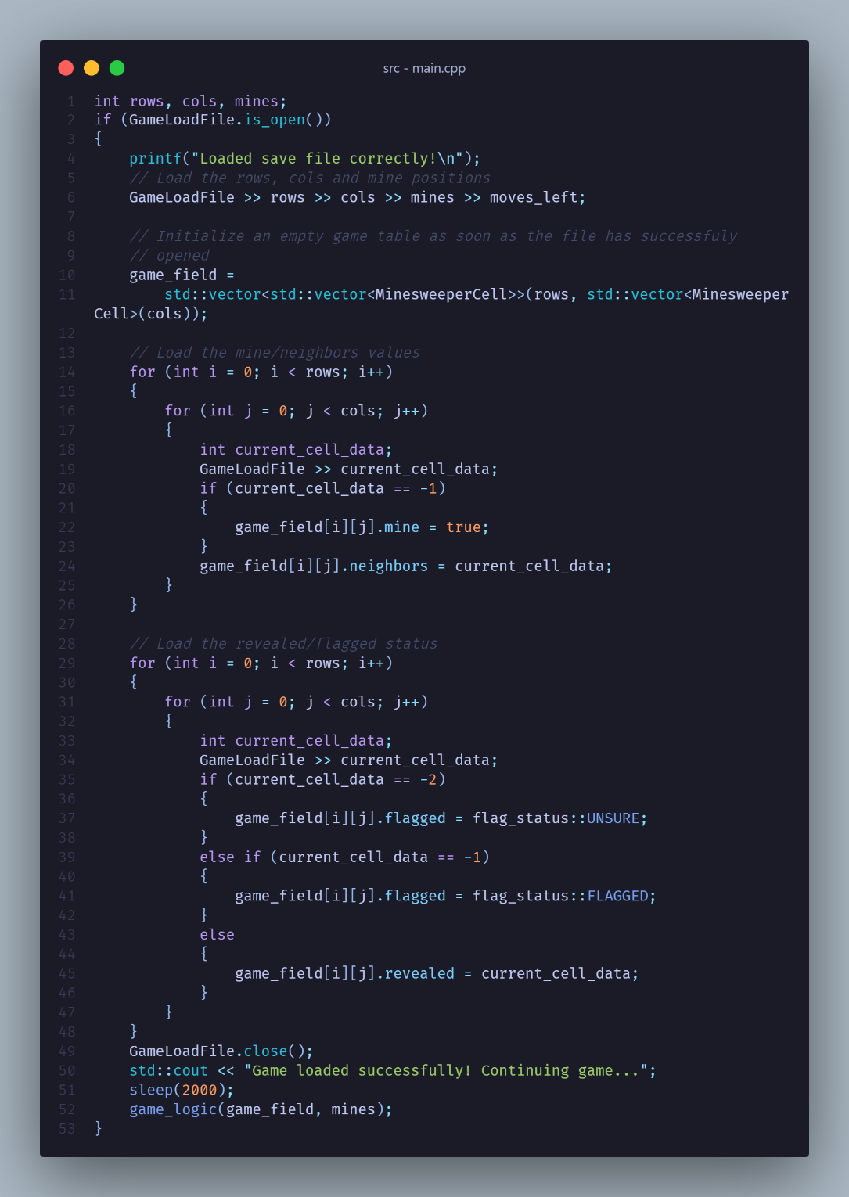
      * Once loaded successfully, the newly created game_field will be handled to the game_logic() function for continue playing.
      * If the game cannot load the game save, then it will instead display the error, then start a new game instead.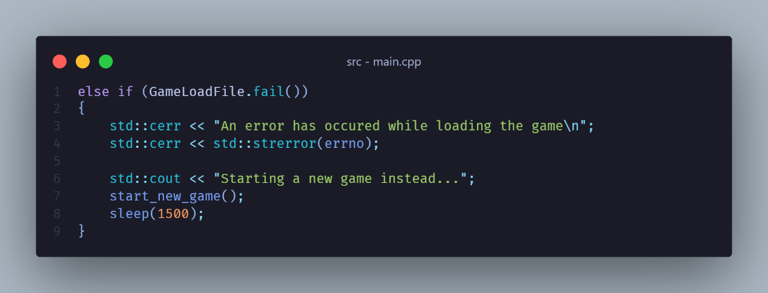

# Personal Remarks

## General

* + While this is not my first project, looking back at the 10-week period of doing this project this is one that made me struggled heavily.
  + Because of my familiarity with Python, returning to C/C++ after a long time staying away from it has been a massive challenge.
  + In addition to not being fluent with the syntax of C/C++, I am very terrible with algorithms, therefore, the code can be ugly for many people.

## What I learned

* + Planning and structuring a project.
  + (Re)learning C/C++.
  + Solving some hard problems.
  + A somewhat OK grasp of *Recursion,* call stack and how not to cause a stack overflow; flood-fill algorithm.
  + Google is still your best friend in coding.

## What needed to be improved

* + **Algorithms!**
  + Simplify parts of code to avoid heavy nesting.
  + Better code and project structure.